PROJECT REPORT

***MOVIES RECOMMENDATION SYSTEM***

BY:

ADITYA SANAP

SHARANDEEP SINGH RAJPAL

SAHIL SAMANT

Problem Statement:

We have developed an AI Model to recommend Movies based on the user’s favorite movie.

We have built this model on Python and its libraries.

System Architecture:

The Python Libraries used to build this model are:

* Numpy: To perform a wide variety of mathematical operations on arrays,
* Pandas: To analyse dataset.
* Difflib: To take input from the user.
* Sklearn: converts text to numericals so we can apply cosine similarity

Flow Chart/Diagram:

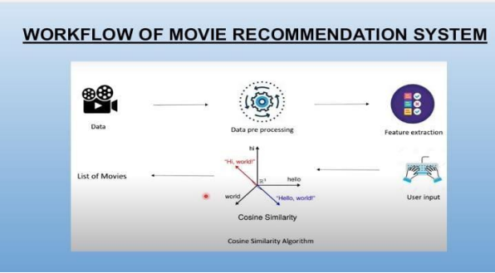

IMPLEMENTATION:

The implementation of this model is based on Cosine Similarity method. i.e. Cosine similarity is a measure used to determine the similarity between two non-zero vectors in an inner product space

As the flow chat depicts we already have the data from the dataset on which preprocessing and extraction is performed.

After that input from the user is taken in the form of his Favorite movie.

And on that input Cosine Similarity method is applied to find similar titles of movies.

And lastly the list is presented to the user.

Output:

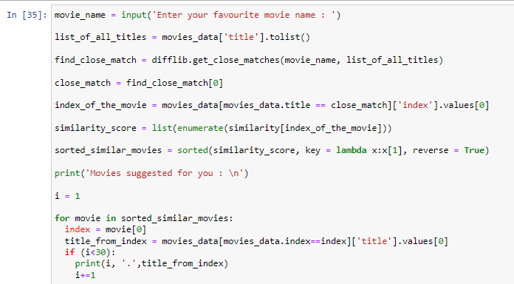

This the main model

Output 1:

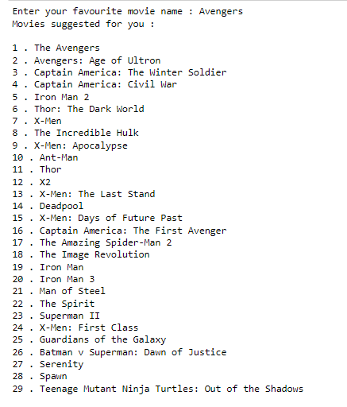

Output 2:

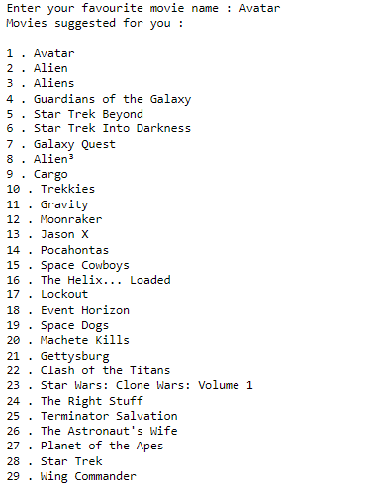

Conclusion:

As we have seen in the output 1 the favorite movie as ‘Avengers’ and the movies recommended by the System are related to Marvel Movies. Same can be said to the other output.

Thus we can confirm that the AI Model we have built works fine.

**Note:** This Model can be upgraded to be used for applications like Netflix, Amazon, and other OTT platforms where the dataset is continuously updated.